**To Supply Leftover Food to Poor**

**Project Overview:-**

**Food Connect** :- It is created to oversee food donation events, distribution, and logistics by utilizing Salesforce's CRM features. It aids in monitoring donors, volunteers, locations, and resources while automating processes such as event planning, communication, and reporting to ensure smooth coordination of food donation and distribution activities.

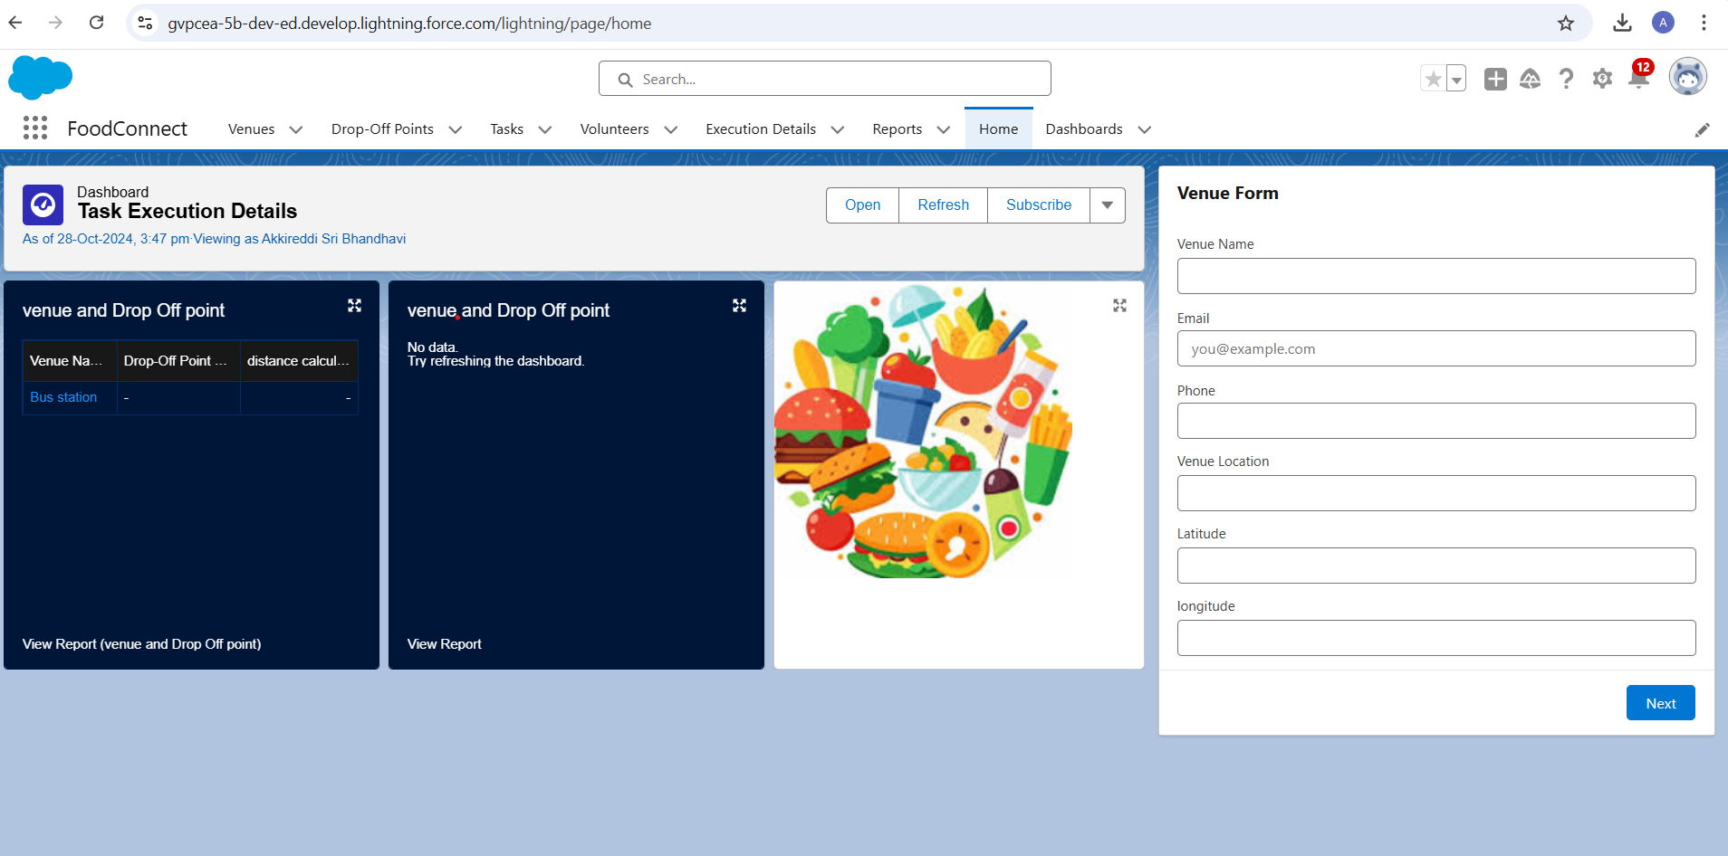

**Objects :-**

**Venue Object:** Venue - Oversees and monitors event locations designated for food collection and distribution in the Food Connect initiative.

**Drop-Off Point Object:** Drop-Off Point - Manages and monitors designated sites for food donations within the Food Connect initiative.

**Task Object:** Task - Organizes and tracks activities and responsibilities associated with food donation events within the Food Connect initiative.

**Volunteer Object:** Volunteer - Administers and tracks individuals who contribute to food donation events and activities in the Food Connect initiative.

**Execution Details Object:** Execution Detail - Oversees and tracks specific operational details and milestones of food donation events in the Food Connect initiative.

**Tabs :-**

Venue Tab: The Venue tab offers users easy access to manage and view all Venue records, enabling effective tracking of locations designated for food donation and distribution events within the Food Connect initiative.

Drop-Off Point Tab: The Drop-Off Point tab provides users with quick access to manage designated donation sites, simplifying the coordination of donation collection logistics.

Task Tab: The Task tab displays a structured overview of tasks and activities associated with food donation events, promoting smoother coordination and task assignment.

Volunteer Tab: The Volunteer tab allows users to oversee and track volunteer participation, ensuring optimal volunteer deployment for various food donation activities.

Execution Detail Tab: The Execution Detail tab enables users to monitor and log detailed operational information for food donation events, enhancing event management and tracking of progress.

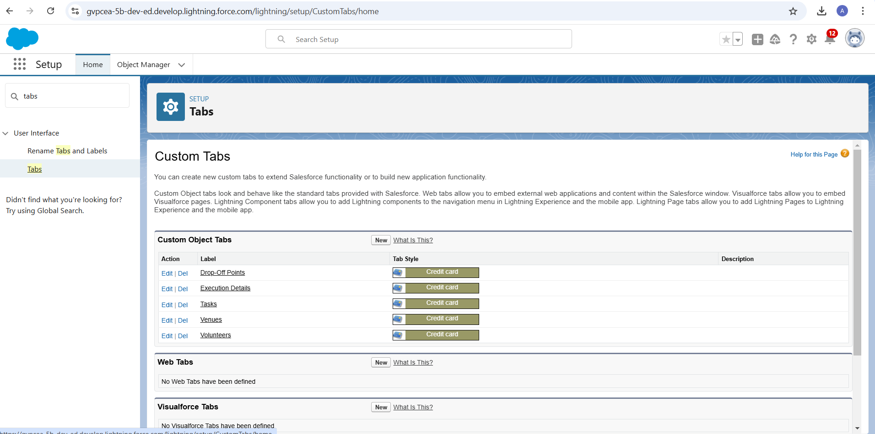

**Lightning App :-**

1. App Name: FoodConnect
2. Developer Name: FoodConnect
3. Image: Optional
4. Primary Color Hex Value: Default
5. Navigation Style: Standard Navigation
6. Utility Items: Default (no custom utility items added)
7. Navigation Items:
   * Home
   * Venue
   * Drop-Off Point
   * Task
   * Volunteer
   * Execution Details
   * Reports
8. User Profile: System Administrator

**Field and Relationships:-**

Lookup Relationship (Volunteer to Drop-Off Point):  
Enables volunteers to be associated with multiple drop-off points, offering flexibility without enforcing strict dependencies.

Master-Detail Relationship (Execution Details to Volunteer):  
Ensures execution details are directly linked to a specific volunteer, supporting data integrity with cascading deletions.

Master-Detail Relationship (Execution Details to Task):

Establishes a dependency where execution details must have an associated task, preserving task context.

Lookup Relationship (Drop-Off Point to Venue):  
Allows drop-off points to be associated with multiple venues flexibly, without enforcing dependencies.

Lookup Relationship (Task to Venue - Sponsored By):  
 Provides an optional link between tasks and venues for sponsorship purposes, without requiring the task’s existence.

Lookup Relationship (Task to Drop-Off Point):  
Allows tasks to optionally connect with drop-off points, supporting tasks that may not need a specific location.

**Flow:-** This flow is structured to automate the creation of records in the Venue object, streamlining data entry and improving user experience. The components included are:

* Screen Flow:  
  Enables user interaction, allowing users to enter data in a structured, organized format.

Components and Their Purpose:

Screen Element (Venue Details):Serves as the user interface for entering key information about the venue.

Text Component (Venue Name): Records the name of the venue, essential for identification.

Email Component (Contact Email): Collects the primary contact email address, supporting venue-related communication.

Phone Component (Contact Phone): Gathers a contact phone number to enable direct communication when needed.

Text Component (Venue Location): Allows users to specify the venue’s address or location, crucial for logistical planning.

Number Component (Latitude): Records the venue’s latitude, aiding in mapping and location-based services.

Number Component (Longitude): Records the venue’s longitude, providing complete geographical coordinates for precise location identification.

Create Record Element (Create Venue Record): Responsible for saving venue data to the database, ensuring all entered information is stored accurately.

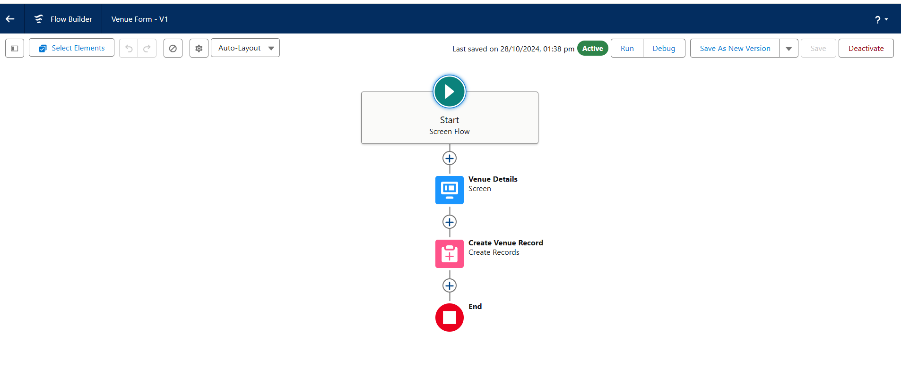

**Trigger:-**

Creating a trigger in Salesforce enables you to automate processes and enforce business rules by executing specific actions whenever records in the Drop-Off Point object are created, updated, or deleted. This feature helps maintain data integrity and improves application responsiveness. 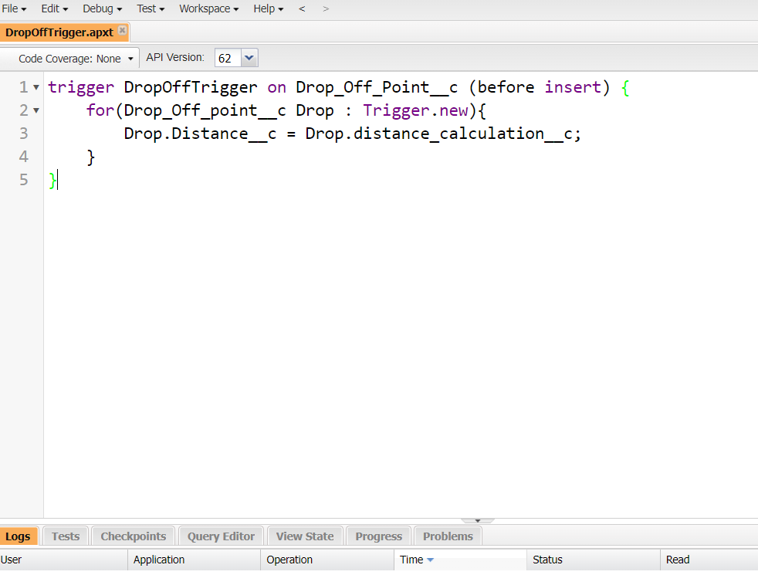

**Profiles:-**

To create a custom profile for specific user access and permissions**.** NGOs Profile.

Creation of User1

* Purpose: To create a new user in Salesforce with specific details tailored for NGO use.
* User Details:
  + First Name: Iksha Foundation
  + Last Name: Iksha_Foundation
  + Alias: iiksh
  + Email: iiksh@gmail.com
  + Username: ikshafoundation@sb.com (ensure it's unique)
  + Nickname: Auto Populated
  + User License: Salesforce Platform
  + Profile: NGOs Profile
  + Active: Checked

This user will be configured to have access tailored for nonprofit operations.

User2:NSS User3:Street_cause

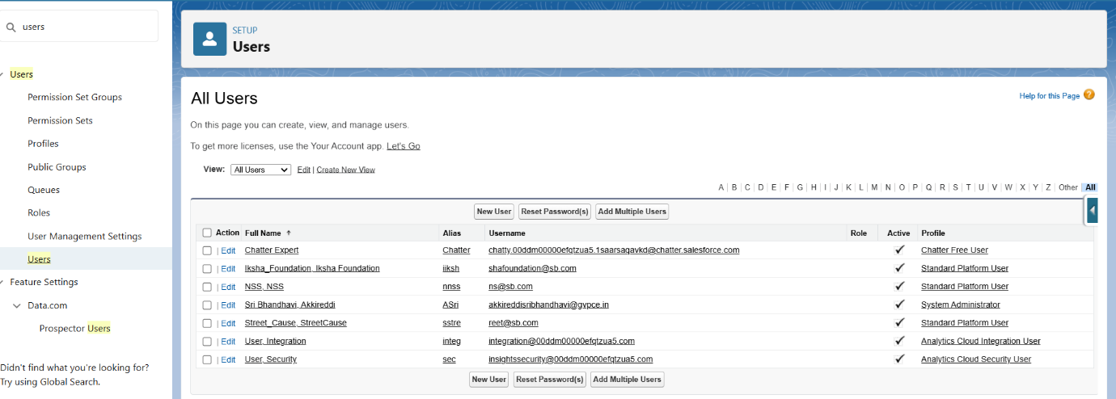

**Report Types:-**To generate custom reports that provide insights on relationships between Venues, Drop-Off Points, and Volunteers.

* Keywords:
  + Primary Object: Venues
  + Report Type Label: Venue with DropOff with Volunteer
  + Report Type Name: Venue_with_DropOff_with_Volunteer
  + Store in Category: Other Reports
  + Deployment Status: Deployed
  + Related Objects: Drop-Off Points, Volunteers
  + Relationship Option: "A" records may or may not have related "B" records

This report type enables the creation of in-depth reports that integrate data from Venues, Drop-Off Points, and Volunteers, supporting efficient data analysis for nonprofit initiatives.

**Reports:-**

Creation of Report on Venue with DropOff with Volunteer

* Purpose: To generate a custom report showing relationships between venues, drop-off points, and volunteers.
* Report Name: venue and Drop Off point
* Report Type: Venue with DropOff with Volunteer
* Group Rows by: Volunteer Name
* Columns: Venue Name, Drop-Off point Name, Distance
* Folder: Custom Reports

This report helps track and analyze volunteer activities across venues and drop-off points, facilitating operational management for nonprofits.

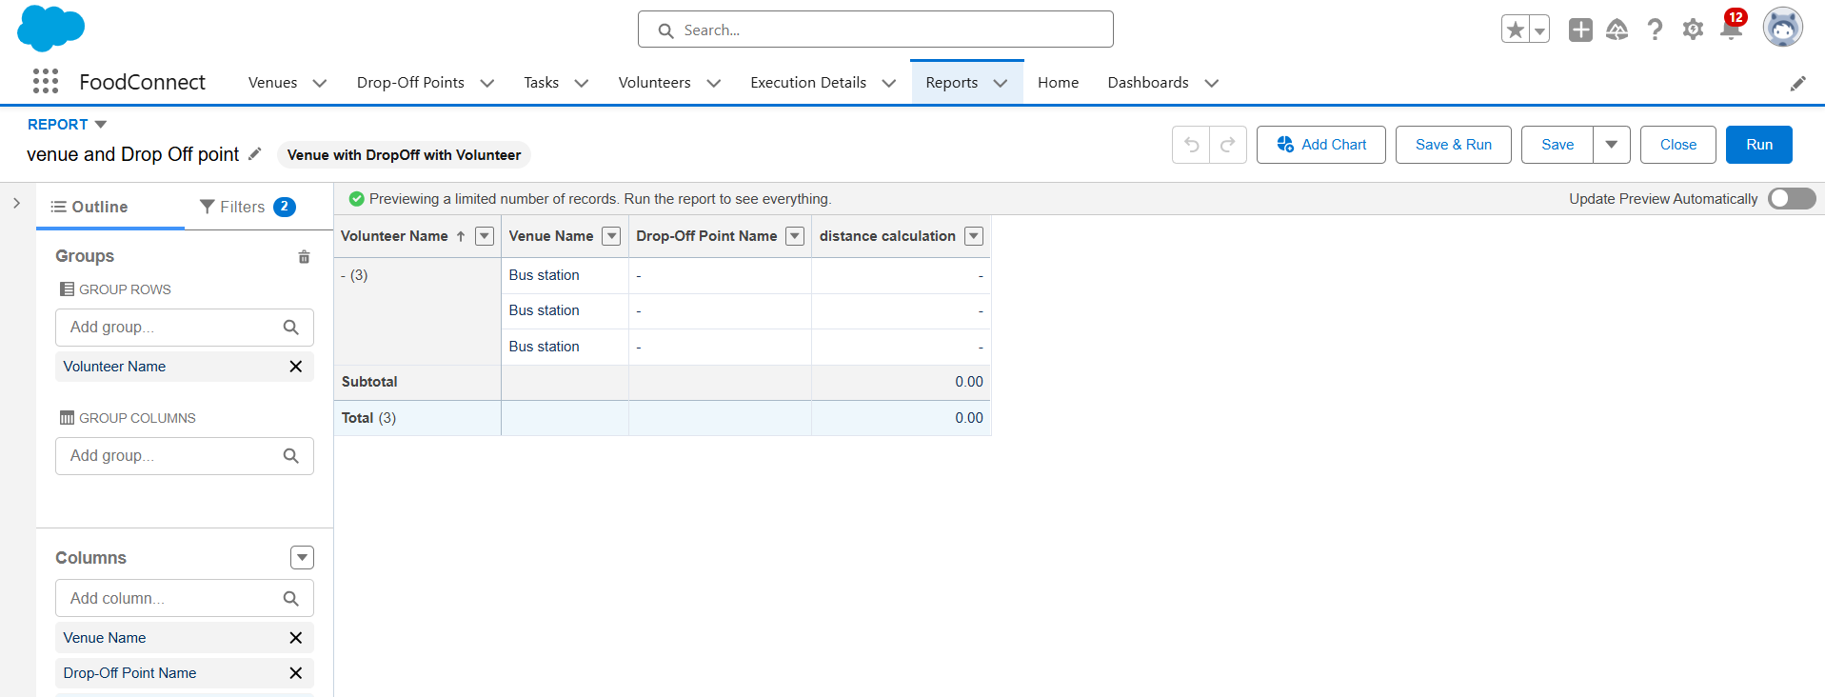

Creation of Report on Volunteers with Execution Details and Tasks

* Purpose: To generate a detailed report showing volunteer tasks, execution details, and performance ratings.
* Report Name: Volunteer Task
* Report Type: Volunteers with Execution Details and Tasks
* Group Rows by: Volunteer ID
* Columns: Volunteer Name, Task Name, Execution Detail Name, Volunteer Owner Name, Task Date, Task Rating
* Folder: Custom Reports

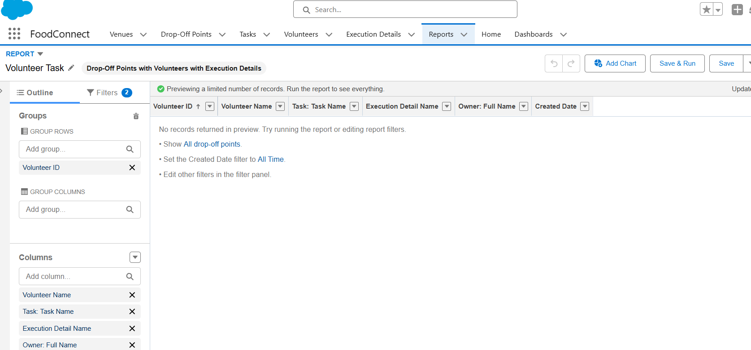

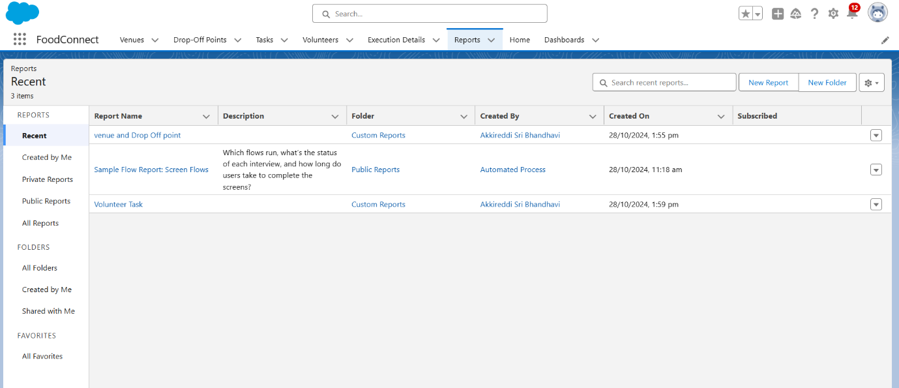

Adding venue and Drop Off point Report to the Dashboard:-

* Purpose: To visualize the "Venue and Drop Off Point" report data on a custom dashboard.
* Dashboard Name: Organization Details
* Folder: Custom Dashboards
* Report Selected: venue and Drop Off point Report
* Display As: Lightning Table
* Component Theme: Dark (Optional)

This allows real-time tracking of venue and drop-off point activities, making it easier to monitor and manage operations from the dashboard.

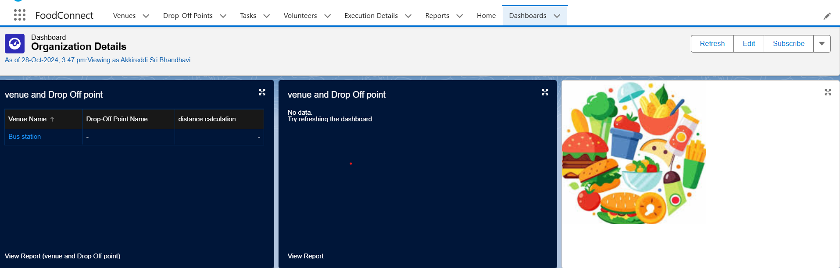

Adding "Volunteer Task" Report to the Dashboard

* Purpose: To visualize the "Volunteer Task" report on the dashboard for task tracking and performance analysis.
* Report Selected: Volunteer Task Report
* Display As: Line Chart
* Component Theme: Dark (Optional)

This setup offers a visual overview of volunteer tasks, facilitating efficient tracking of task progress and volunteer performance directly from the dashboard.

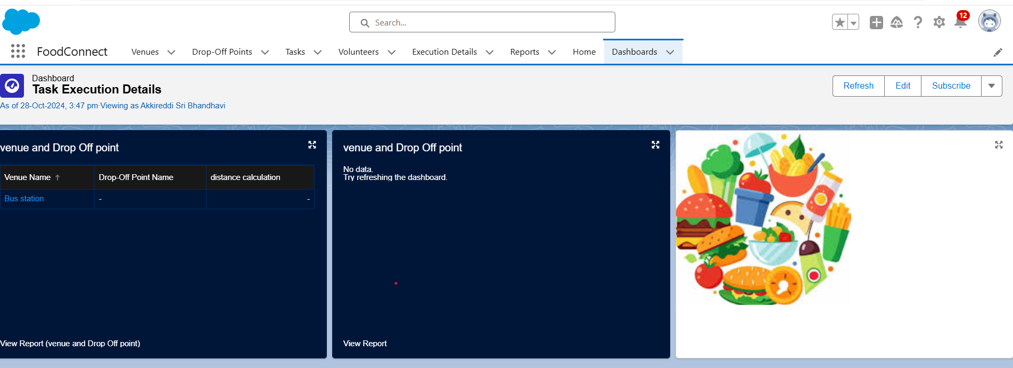

Creation of Sharing Rules

* Purpose: To control and manage access to Drop-Off point records based on distance criteria for different user groups.
* Rules:
  + Rule 1: Share Drop-Off points with a distance of less than 15 units with the "Iksha" Public Group.
  + Rule 2: Share Drop-Off points with a distance between 15 and 30 units with the "NSS" Public Group.
  + Rule 3: Share Drop-Off points with a distance between 30 and 50 units with the "Street Cause" Public Group.

**Home Page:-**

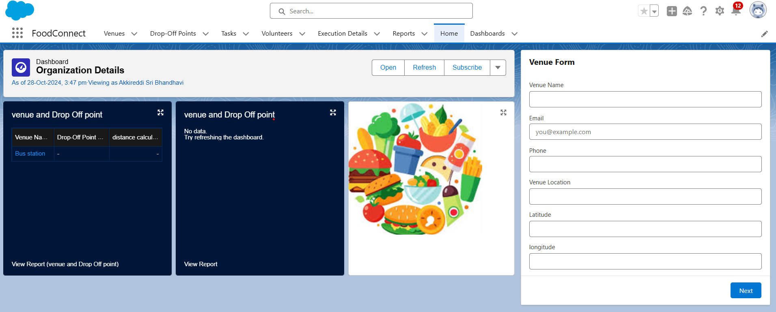

**Conclusion:-**

The custom Home Page for the FoodConnect App incorporates essential components like the Venue Flow and Dashboard, giving users a centralized interface to manage core functionalities. By tailoring the home page layout with these interactive elements, users can quickly access reports, workflows, and critical organizational data, improving productivity and enhancing the overall user experience within the FoodConnect application.

**SALESFORCE URL:**

https://gvpcea25-dev-ed.develop.my.salesforce.com/